Module 4 Exam Summer 20
Student’s Name
Date

  - According to Classical economists, deviations from full employment (booms and recessions) are due to adjustments from shifts in the labor supply and demand curves. These shifts were discussed in chapters 10. Why do Keynesian economists argue this point?
Solution
Classical economists argued that full employment was general condition and any deviation from full employment is corrected through the flexible wage rate and interest rate. However, Keynesians do not agree with this proposition in the sense that, they argue that wage rate is not flexible enough to adjust during the fall in aggregate effective demand. Hence, wage rate remains high even during the period of recession or deficient demand. Thus, government must intervene here to increase aggregate effective demand to correct imbalances in economic activities.
  - Below are the points to an AE curve. Calculate the slope and complete the schedule below. Hint words: Linear relationship.
Income Aggregate Expenditures (C + I + G)
$750 $1500
$1750 $2250
$2750 --------
$3750 _____

$5200 $4500
$6200 _____

Solution
Y-Y₁=$\frac{Y2-Y1}{X2-X1}$ (X-X₁)

Y₁ AE₁ Y₂, AE₂
(750, 1500) (1750, 2250)

Y-750 = $\frac{1750-750}{2250-1500}$ (AE-1500)

(Y-750)= $\frac{1000}{750}$ (AE-1500)

(Y-750)= $\frac{4}{3}$ (AE-1500)

3Y-2250=4(AE-1500)

3Y-2250=4AE-6000

AE=3/4Y+937.50

AE=0.75y+937.50

So, At Y=2750
AE=3/4 (2750) + 937.5
=3000
At Y=3750
AE=3/4 (3750) + 937.5
=3750
At y=6200
AE=3/4 (6200) + 937.5
=5587.5
Income | Aggregate Expenditure
750 | 1500
1750 | 2250
2750 | 3000
3750 | 3750
5200 | 4500
6200 | 5587.5

Slope is measured in the ratio of change in vertical axis to change in horizontal axis.
Slope= $\frac{2250-1500}{1750-750}$
$$\frac{750}{1000}$$
=0.75
Values are:
Income | Aggregate Expenditure
750 | 1500 | (750-1500)= | -750
1750 | 2250 | (1750-2250)= | -500
2750 | 3000 | (2750-3000)= | -250
3750 | 3750 | (3750-3750)= | 0
5200 | 4500 | (5200-4500)= | 700
6200 | 5587.5 | (6200-5587.5)= | 612

  - Draw this graph complete with a 45 degree AP line.
AE
45 degree line.

AP

*
700

0 Y

  - At what level of output (income) will this economy operate? In other words, what point is equilibrium?
Solution
The level of output is the value where planned expenditure is equal to the actual expenditure
Here, the income 3750, is the level of output in which the economy will operate
  - Line up this AE/AP graph above an inverted aggregate production graph. Demonstrate with a dotted line that there is a recessionary gap where potential output is $5850.
Solution
The curve current output = 3750 and Potential output =$5850
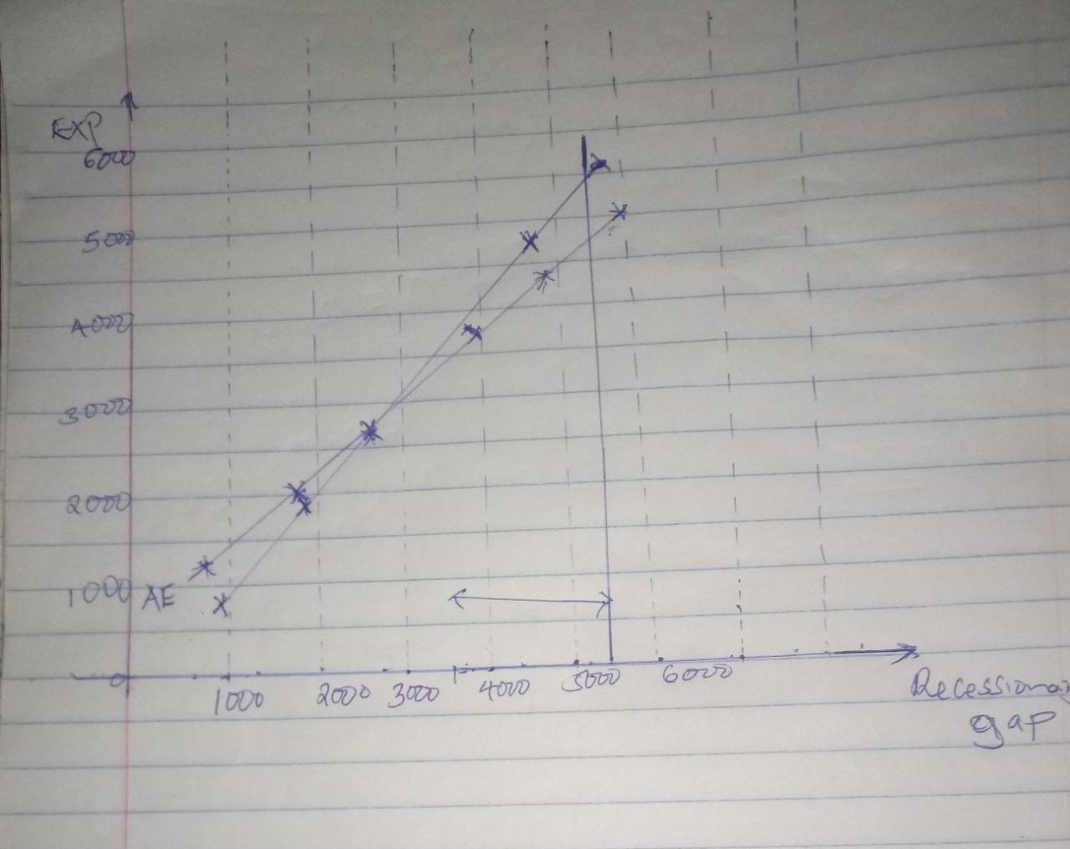
  - How much of a gap is there? Show work

Solution
Gap present =Potential output- current output
5850-3750
= 2100
  - What is the MPS? Show work.
Solution:
Given the linear equation as
AE=0.75y+937.50
Where by the MPC =0.75 (Slope)
Then, the MPS= 1- slope of the curve.
MPS=1-0.75 (slope).
MPS=0.25
  - What is the Multiplier? Show work.
Solution
Multiplier is $\frac{1}{MPS}$= $\frac{1}{0.25}$ = 4
Therefore, Multiplier is equal to 4
  - The government can close this gap two ways. They can increase government expenditures by $ 525 or they can reduce taxes by $700. Show all work.
Solution

Multiplier = 1 / MPS = 1 / 0.25 = 4 [This is government spending multiplier]
Tax multiplier = - (MPC / MPS) = - (0.75 / 0.25) = -3 [The minus sign shows the negative relationship]
The government can increase government expenditure by = $2100 / 4 = $525
The government can reduce taxes by = $2100 / 3 = $700

